Peter is an employee of salesforce reaching the apple here salesforce is a customer, and peter is point of contact

Lead is a child object, campaign is a parent object

This is relationship is lookup

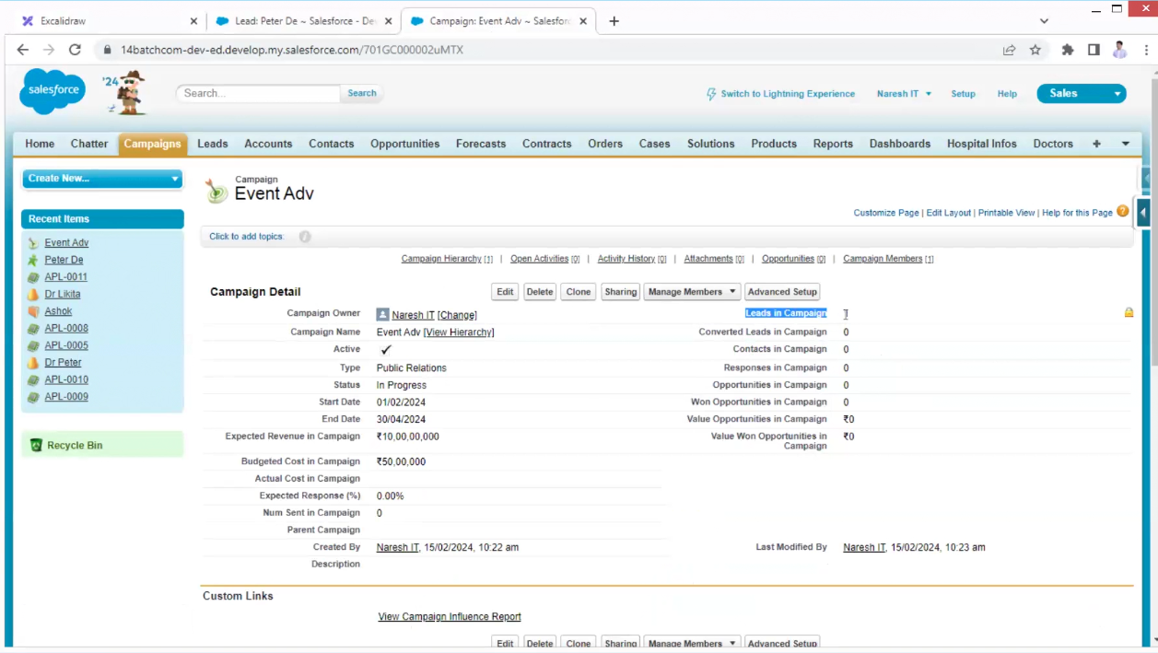

I need to segregate the information separately like organization one and other is person we have a option convert

In above case from task to Account from Account to contact if he buys the product the opportunity closed

Then contact becomes customer

31 minutes pending